Island-born teacher crafts colourful, mythical tale in debut novel
By Lori Thompson
June 20, 2018
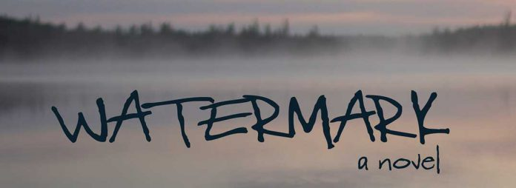Farquhar Book Launch
MANITOULIN––’Watermark,’ the debut novel by Manitoulin-born Jennifer Farquhar, is a coming of age story 20 years after the fact. It is a loving tribute to growing up in Northern Ontario (on Manitoulin Island) in the 1970s and 80s, and to the unique relationships forged between Indigenous and non-Indigenous peoples living side-by-side in a magical – although occasionally terrifying – landscape.
Marina McInnis is an adult whose growth was stunted at the age of 14, when her life was transformed by a series of tragic incidents that caused her to run away and build herself a new life.
Circumstances force her return to the island 20 years later, towing along her adored but precocious teenage son. Although she initially refuses to face the past, the past comes to her, as it is prone to do. Marina is required to re-examine her role in the tragedies and unravel the truth to events that were put in motion before her time.
Farquhar’s prose lovingly dances over the geography of her own childhood, revisiting the activities of her youth: gathering morels, deer hunting, ice fishing, the smelt run, snowmobiling, boating and the realities of local children mixing with wealthier tourists for that short summer season each year. She lingers over childhood tales that explore sometimes dark Anishinabe lore made darker by a natural childish propensity to embellish scary tales.
Island born author Jennifer Farquhar has written a debut novel ‘Watermark’ that crafts a colourful, mythical take.
It is the juxtaposition of beauty and childish innocence beside the horrors of events that unfold over several summers on Mikinaak Island, a stand-in for Manitoulin, that makes this novel so compelling. What actually occurs, and the guilt that is placed on the shoulders of a child, ultimately cause Marina to choose running away as the best option throughout her life.
Anyone who has experienced a long separation from home understands that feeling of being torn, of nostalgia for one’s roots – of imagining things will stay the same. Hoping that they have while feeling a little frightened that they are. Revisiting the places that once held deep mysteries but now appear benign. How does one find out what really happened in that far off childhood? How real are the memories that haunt us? Yet it is her homecoming that sets in motion the unraveling of the truth and ultimately, Marina’s redemption and discovery of a place to call home.
Those who have made the journey home, who have felt loss and renewal, or who are especially nostalgic for life in the 1970s, and particularly enjoying the beauty and wonder of Manitoulin Island, will enjoy this story from beginning to end. Jennifer Farquhar is a masterful storyteller who will take you on a wavy ride.
‘Watermark’ is published by Latitude 46 Publishing and is available to purchase at The Manitoulin Expositor office. The Expositor will be hosting a book launch on July 1 in Little Current with an author meet and greet hosted by Bonnie Kogos.

